
Sec: JR_*CO-SC(MODEL-B) CTM-10 Date: 04-09-22
Time: 3 Hrs Max. Marks: 300
Key Sheet
PHYSICS
1 | A | 2 | C | 3 | D | 4 | C | 5 | C
6 | C | 7 | D | 8 | B | 9 | A | 10 | B
11 | D | 12 | A | 13 | D | 14 | B | 15 | A
16 | B | 17 | D | 18 | C | 19 | B | 20 | B
21 | 4 | 22 | 3 | 23 | 6 | 24 | 9 | 25 | 5
26 | 6 | 27 | 105 | 28 | 21 | 29 | 6 | 30 | 144

CHEMISTRY
31 | A | 32 | C | 33 | B | 34 | A | 35 | C
36 | D | 37 | B | 38 | A | 39 | C | 40 | B
41 | D | 42 | C | 43 | D | 44 | A | 45 | D
46 | C | 47 | B | 48 | B | 49 | C | 50 | D
51 | 5 | 52 | -3 | 53 | 5 | 54 | 3 | 55 | 3
56 | 2 | 57 | 2 | 58 | 3 | 59 | 6 | 60 | 8

MATHEMATICS
61 | C | 62 | C | 63 | C | 64 | A | 65 | C
66 | C | 67 | D | 68 | C | 69 | A | 70 | A
71 | D | 72 | A | 73 | C | 74 | D | 75 | A
76 | A | 77 | C | 78 | C | 79 | C | 80 | D
81 | 21 | 82 | 0 | 83 | 5 | 84 | 1 | 85 | 8
86 | 2 | 87 | 0 | 88 | 4 | 89 | 1 | 90 | 0
SOLUTIONS
PHYSICS
1. 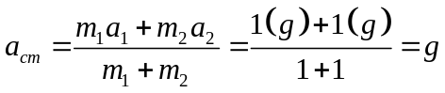
2. 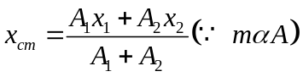
3. Find 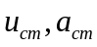, then use 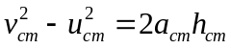
Finally find 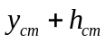
4. 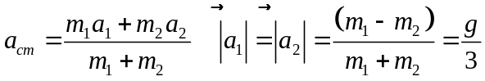
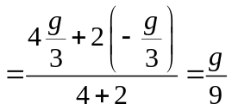
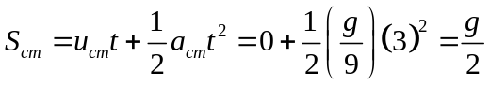
5. given 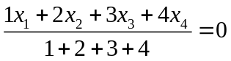
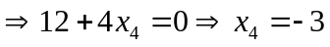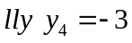
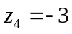
6. 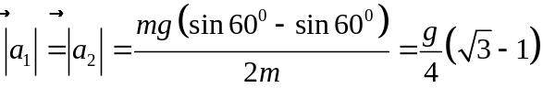
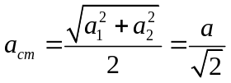
9. 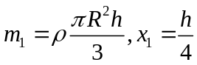
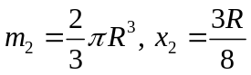 use 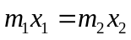
10. 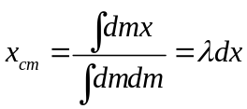
11. 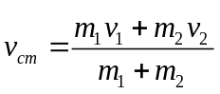
12. net external force is zero
Acceleration of centre of mass is zero
13. 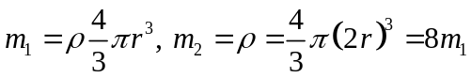
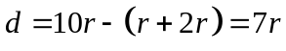
Distance of COM from 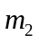 is 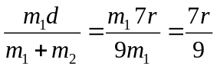
14. 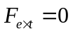, no shift of COM
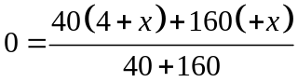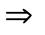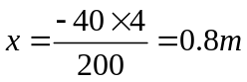
15. 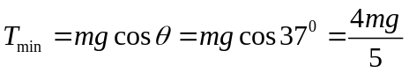
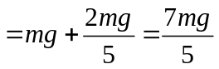
17. 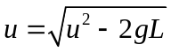
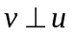, 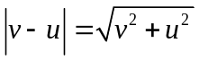
18. 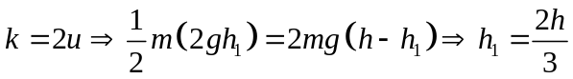
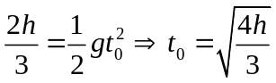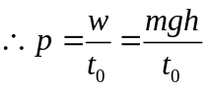
19. 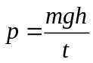
21. 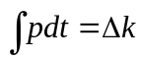
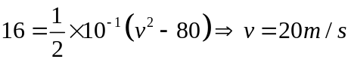
22. 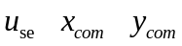
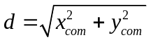
24. 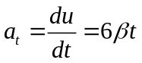,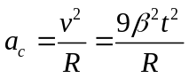
Use 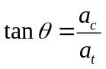
25. 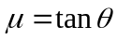
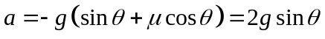
Use 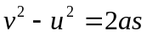
26. 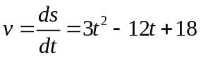
For to be min. or max 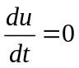
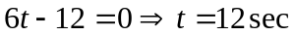
At 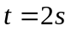
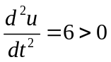. i.e is min. at 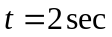
27. Time of flight 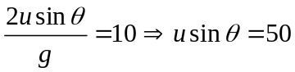
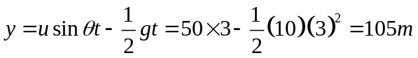
28. 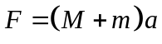
F becomes max when 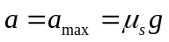
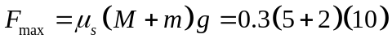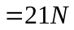
29. 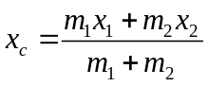
30. use 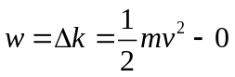
CHEMISTRY
31. Conceptual
32. 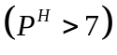at neutralization for W.A & S.B
33. 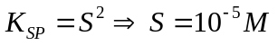
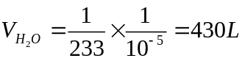
34. 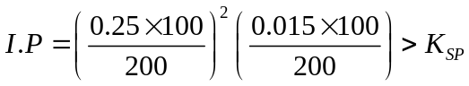
35. Solubility increases on removing OH⁻ i.e of 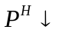
36. Conceptual
37. Conceptual
38. 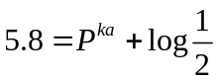
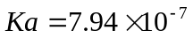
39. 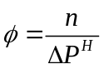
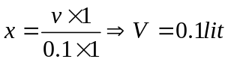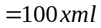
40. Due to common ion effect solubility resulting in 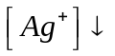
41. Even, if ‘S’ is same, K_{SP} need not be same
42. 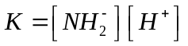
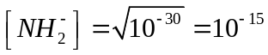
Mole 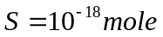
No. of 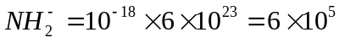
43. 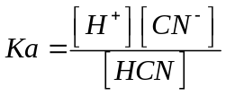
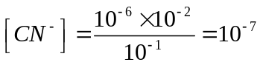
44. 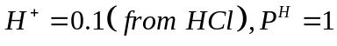
45. Conceptual
46. 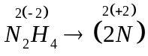
47. No.of Balloons 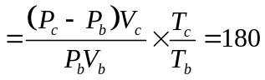
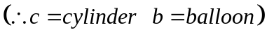
48. Adiabatic expansion cooling effect observed 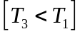
49. 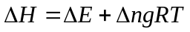
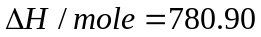
For 39 g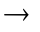390.45kCal
50. Conceptual
51. 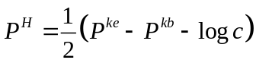

52. 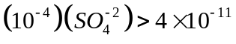
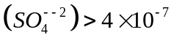
Moles=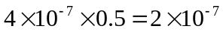
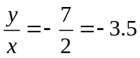
53. 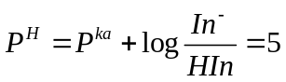
54.
55. 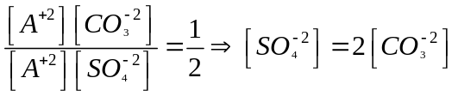
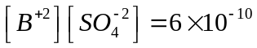
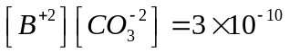
56. 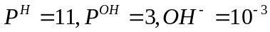
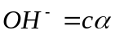
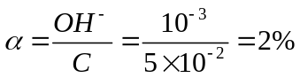
57. 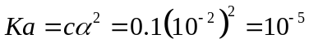
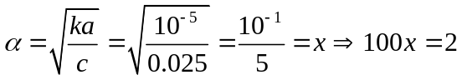
58. 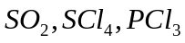 (having lone pairs and octet)
59. 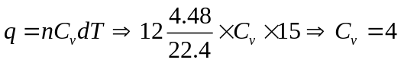
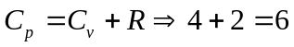
60. 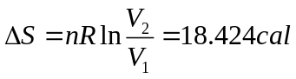
MATHS
61. 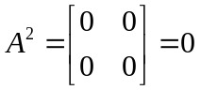
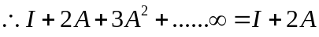
62. 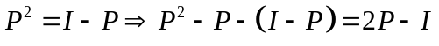
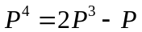
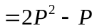
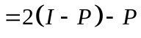
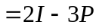
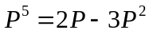
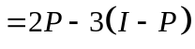
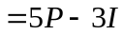
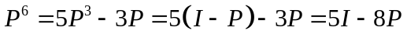

63. 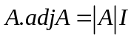
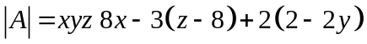
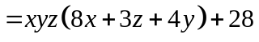
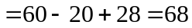
64. 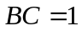
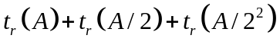
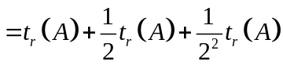
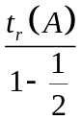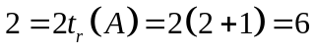
65. 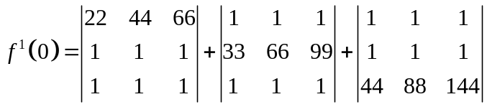
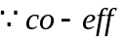 of 
66. 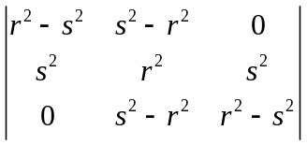
67. 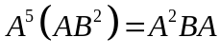
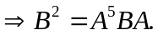
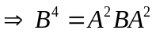
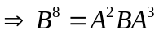
68. Conceptual
69. 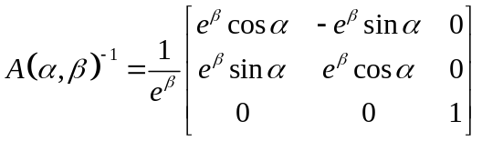
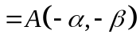
70. From given data 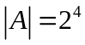
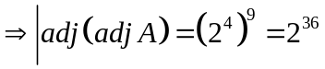
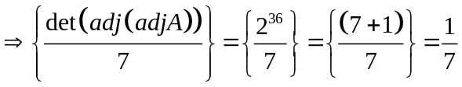

71. 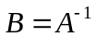
72. Conceptual
73. 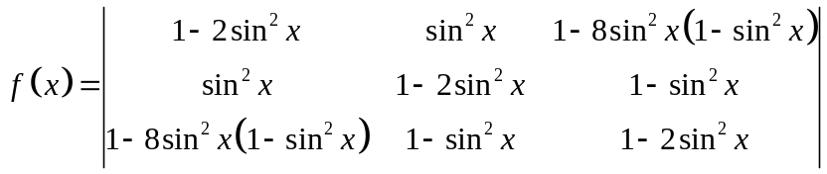
 the required constant term is
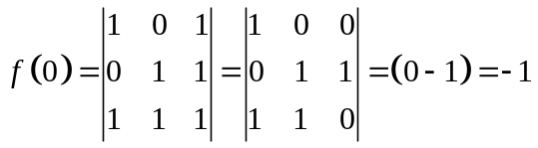
74. 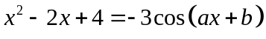
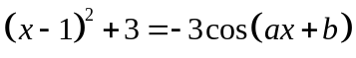
L.H.S 3 & R.H.S 3
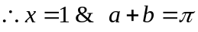
75. 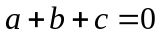 roots are 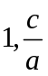
76. 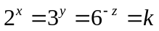
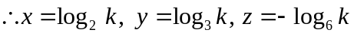
77. 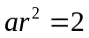
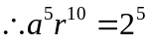
78. Conceptual
79. 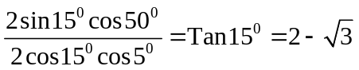
80. 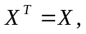 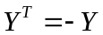
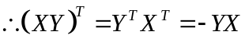
81. 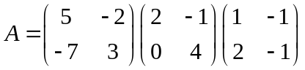
82. 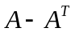 is skew symmetric matrix
83. Let 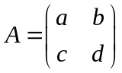
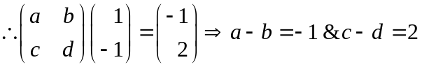
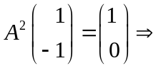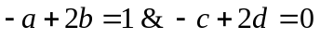
By solving 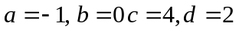
84. 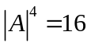
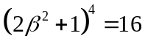
 Real values of 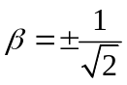
85. 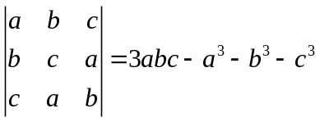
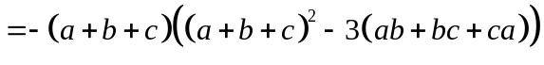
86. 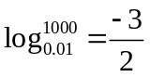
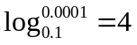
87. 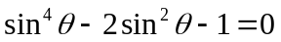
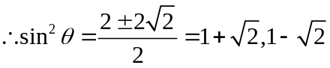
Both are not possible
88. 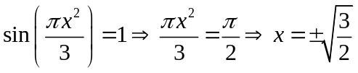
y also get 2 values
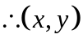 has 4 values
89. 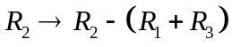
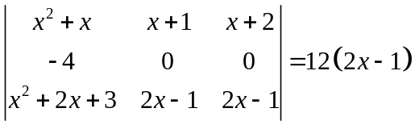
90. Conceptual

